Student Name: _____________________________________
+____/ 412 points

CB: _____________________________

Period: _______ Date Due:_______/______/_______

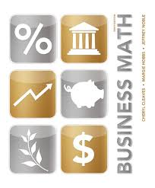
Business Management
______________________________________________
How to
Start & Operate
a Small Business

A Guide for
THE YOUNG ENTREPRENEUR

Mathematics & Business Math

Skills - Level 2

FOR ENTREPRENEURS

2.1 Cost of Goods Sold (COGS)

2.2 Gross Profit (GP)

2.3 Income Statements

2.4 Return on Investment (ROI)

_______
San Leandro Business and Finance Academy

The Network for Teaching Entrepreneurship, Inc. (NFTE)
120 Wall Street, 29th Floor, New York, NY 1005

+_____/ 185pts 2.1 Cost of Goods Sold (COGS)

Example: The cost of goods (or services) sold can be thought of as the cost of selling “one additional unit.” Find the Cost of Goods Sold (COGS) for one complete leather jacket:
- calculate the cost of each type of material used to make one jacket
- then, add those costs to calculate the total COGS of one jacket.

Needed to Make One Jacket | Unit Cost of Material | Calculation | Cost  of Material
3 yards of leather | $10.00 per yard | Think, 3 yards are needed, and one yard costs $10.00, so...  3 X 10 = | $30.00
3 yards of Thinsulate® | $8.00 per yard | 3 X 8 = | $24.00
3 yards of nylon | $4.00 per yard | 3 X 4 = | $12.00
1 zipper | $129.60 per gross  (1 gross = 12 dozen) | Think: 12 X 12 = 144, so... 129.60 ÷ 144 = | $ 0.90
Thread | $0.25 | $0.25 X 1 = | $ 0.25
Total Cost of Goods Sold for One Complete Jacket |  |  | $67.15

+____/6 A. Try It: The Cost of Goods Sold (COGS) for One Beaded Necklace

Needed to Make  One Necklace | Unit Cost of Material | Calculation | Cost of  Material
12 coral beads | $3.60 per dozen | $3.60 =
1 clasp | $2.40 per dozen | $2.40 ÷ 12 =
12 gold beads | $0.50 each |  | $6.00
__ turquoise beads | $1.00 each |  | $6.00
__ inches nylon string | $0.02 per yard |  | $0.01
Total Cost of Goods Sold for One Beaded Necklace

Provide the missing information to complete each chart.

+____/7 B. The Cost of Goods Sold (COGS) for One Sling Bag

Materials Needed | Unit Cost | Calculation | Cost of Material
¾ yard floral chintz fabric | $12.00 per yard
¾ yard lining material | $4.00 per yard
Thread | $0.75
Total Cost of Goods Sold

+____/7 C. The Cost of Goods Sold (COGS) for One Baby’s Bib

Materials Needed | Unit Cost | Calculation | Cost of Material
¼ yard terry cloth material | $8.00 per yard
1 yard binding | $0.50 per yard
1 duck emblem | $0.25
Total Cost of Goods Sold

+____/13 D. The Cost of Goods Sold (COGS) for One Tie-Dyed T-Shirt

Materials Needed | Unit Cost of Material | Calculation | Cost of Material
1 cotton T-shirt | $432.00 per gross  (1 gross = 144)
¼ oz. blue dye | $4.00 per oz.
¼ oz. green dye | $4.00 per oz.
¼ oz purple dye | $4.00 per oz.
1/8 cup soda ash | $1.60 per cup
15 rubber bands | $0.01 each
Total Cost of Goods Sold

+____/9 E. The Cost of Goods Sold (COGS) for a Hair Scrunchy

Materials Needed | Unit Cost of Material | Calculation | Total Cost of Material
1 elastic band | $2.40 per dozen |  | $
1 silk daisy | $4.80 per dozen |  | $
2 silk leaves | $0.08 each |  | $
thread | $0.20 |  | $
Total Cost of Goods Sold |  |  | $

+____/9 F. The Cost of Goods Sold (COGS) for a Quartz Clock

Materials Needed | Unit Cost of Material | Calculation | Total Cost of Material
1 quartz clock movement | $575.00 for 50 |  | $
1 pre-cut clock case, paint, and numerals | $225.50 for 50 |  | $
Total Cost of Goods Sold |  |  | $

+____/9 G. The Cost of Goods Sold (COGS) for a Customized Jump Rope

Materials Needed | Unit Cost of Material | Calculation | Total Cost of Material
4 feet of clothesline | $0.02 per foot |  | $
2 smokestack peg handles | $0.35 each |  | $
½ oz. pink oil paint | $13.00 per 8 oz. |  | $
½ oz. white oil paint | $13.00 per 8 oz. |  | $
Total Cost of Goods Sold

+____/11 H. The COGS for an Apple-Shaped Candle

Materials Needed | Unit Cost of Material | Calculation | Total Cost of Material
16 oz. paraffin | $14.08 for 10 Ibs.  (1 pound = 16 oz.) |  | $
½ oz. red color cake | $1.71 per ½ oz. |  | $
4 inches cotton wicking | $.005 per inch |  | $
1 plastic apple | $4.00 per bag of 10 |  | $
½ oz. styrene | $0.14 per oz. |  | $
Total Cost of Goods Sold |  |  | $

+____/9 I. The COGS for a Seed-Starter Tray

Materials Needed | Unit Cost of Material | Calculation | Total Cost of Material
3 biodegradable seed pots | $0.14 each |  | $
12 basil seeds | $0.05 each |  | $
16 oz. soil  (1 pound = 16 oz.) | $16.95 for 50 pounds |  | $
8 feet wooden slatting  for tray | $0.20 per foot |  | $
hot glue | $0.50 |  | $
1 yard of ribbon | $5.75 per 100 yards |  | $
1 hand-printed label | $0.10 |  | $
Total Cost of Goods Sold |  |  | $

+____/9 J. The COGS for a Sea Shell Picture Frame

Materials Needed | Unit Cost of Material | Calculation | Total Cost of Material
1 wooden 5” x 7” frame | $36.00 per dozen |  | $
20 assorted sea shells | $0.25 each |  | $
hot glue | $1.00 |  | $
Total Cost of Goods Sold |  |  | $
+____/9 K. The COGS for a Wooden Bird Feeder

Materials Needed | Unit Cost of Material | Calculation | Total Cost of Material
2 feet of plywood | $3.00 per foot |  | $
hot glue | $ 1.00 |  | $
nails | $0.25 |  | $
paint | $1.00 |  | $
1 hanger attachment | $1.99 for 20 |  | $
Total Cost of Goods Sold |  |  | $

+____/7 L. The COGS for Dupe of a Demo Tape

Materials Needed | Unit Cost of Material | Calculation | Total Cost of Material
1 audio cassette and  plastic case | $750.00 for case  of 250 |  | $
I hour engineer's time | $40.00 per hour |  | $
1 label | $54.00 per 1000 |  | $
Total Cost of Goods Sold |  |  | $

+____/7 M. The COGS for one square of Rice Krispies® Treat (Note: This recipe makes 12 three-inch square Rice Krispies® Treats. Find the COGS for one square.)

Materials Needed | Unit Cost of Material | Calculation | Total Cost of Material
10 oz. marshmallows | $1.99 for 10 oz. bag |  | $
6 cups Rice Krispies® | $0.18 per cup |  | $
3 tablespoons margarine | $0.03 per tablespoon |  | $
Total Cost of Goods Sold |  |  | $

+____/7 N. The COGS for one Hand Printed Greeting Card

Materials Needed | Unit Cost of Material | Calculation | Total Cost of Material
1 ready-cut blank  white vellum card | $21.60 per gross  (1 gross = 144) |  | $
1 hand-cut initial stamp | $1.00 |  | $
ink | $0.10 |  | $
Total Cost of Goods Sold |  |  | $

+____/7 O. COGS for a Customized DVD-Case Cover

Materials Needed | Unit Cost of Material | Calculation | Total Cost of Material
1 plastic DVD case | $25.00 for 25 |  | $
1 color photocopy | $1.00 |  | $
marbleized paper  7” x 9” | $0.69 per 7” x 9” sheet |  | $
Total Cost of Goods Sold |  |  | $

+____/7 P. COGS for a Wooden Window Box

Materials Needed | Unit Cost of Material | Calculation | Total Cost of Material
16 feet of slat lumber | $0.20 a foot |  | $
1 plastic 9" x 24”  window box liner | $14.75 for 25 |  | $
glue/nails | $ 1.00 |  | $
Total Cost of Goods Sold |  |  | $

+____/15 Q. COGS for one Soft-Shell Crab Sandwich

Materials Needed | Unit Cost of Material | Calculation | Total Cost of Material
1 soft-shell crab | $27 per dozen |  | $
1 oz. cornmeal | $0.03 |  | $
1 sourdough roll | $0.25 |  | $
1/5 tomato (slice) | $0.05 |  | $
lettuce leaves | $0.03 |  | $
mayonnaise | $0.06 |  | $
oil for frying | $0.10 |  | $
Total Cost of Goods Sold |  |  | $

+____/7 R. COGS for Black and White Milkshake

Materials Needed | Unit Cost of Material | Calculation | Total Cost of Material
1 cup vanilla ice cream | $1.28 per cup |  | $
1 cup milk | $0.17 per cup |  | $
3 tablespoons chocolate | $0.30 |  | $
Total Cost of Goods Sold |  |  | $

+____/15 S. The COGS for one Gift Basket

Materials Needed | Unit Cost of Material | Calculation | Total Cost of Material
1 basket | $24.00 per dozen |  | $
2 lb. cheddar cheese |  |  | $3.00
1 canned ham | $120.00 per dozen |  | $
3 jars of jam |  |  | $3.00
6 oranges | $2.00 per dozen |  | $
1 box crackers |  |  | $2.00
Cellophane wrap bag | $0.50 for full basket bag |  | $
Total Cost of Goods Sold |  |  | $

+____/7 T. The COGS for one Windsock

Materials Needed | Unit Cost of Material | Calculation | Total Cost of Material
½ yard rip-stop nylon |  |  | $4.00
1 team emblem | $3.00 per dozen |  | $
Thread |  | 1 X $0.75 | $
1 swivel hardware | $____ for 24 |  | $0.04
Total Cost of Goods Sold |  |  | $5.04

Item | Cost
apple | $6.60/doz.
muffin | $9.00/doz.
fresh burrito | $5.50 ea.
deli sub sandwich  (each serves 4 people) | $10.10 ea.
deli hot dog | $3.15 ea.
bag of pretzels | 30 for $4.99
bag of corn chips | 12 for $5.99
banana | $01.79/lb.  (5 bananas)
bags of carrot and celery sticks  with Ranch dip | $3.00/lb  (1 lb. serves 15 people)
lunch bags | 100 for $2.50
soda | $0.50/can
bottled water | $0.30/bottle
napkins | 300 for $2.59
paper plates | 25 for $6.25
+____/8 U. Tiago teaches and sells computer training courses. He provides lunch to each person who takes his one-day Internet training class. Create a tasty and healthy lunch menu that would cost Tiago under $4.05 per person in materials. Pick from only the items in the chart. Spend as close to $4.05 without going over as you can.

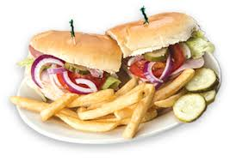
+_____/ 31pts 2.2 Gross Profit

Gross profit per unit is the selling price per unit Selling Price per Unit minus the cost of goods sold (COGS) per unit. − COGS per Unit
Gross Profit per Unit

Total gross profit is total revenue minus total cost of goods sold. Total Revenue
− Total COGS
Total Gross Profit

Example: If the selling price to a consumer for one leather bomber jacket is $250.00 and its cost of goods sold is $67.15, what is the gross profit? $250.00
- 67.15
The gross profit for the jacket is $182.85. $182.85

Item | Consumer Price | COGS | Gross Profit
beaded necklace | $25.00 | $15.81 | $
windsock | $10.00 | $5.04 | $
sling bag | $29.95 | $12.75 | $
holiday basket | $60.00 | $16.50 | $
+______/4 B. Determine the gross profit for each of the following items

+______/9 B. Determine the gross profit for each of the following items
Item | Consumer Price | COGS | Gross Profit
baby bib | $6.95 | $2.75 | $
tie-dyed t-shirt | $12.95 | $6.35 | $
hair scrunchy | $5.00 | $0.96 | $
quartz clock | $39.00 | $16.01 | $
jump rope | $10.00 | $2.40 | $
apple candle | $8.00 | $3.60 | $
seed- starter tray | $12.00 | $3.08 | $
sea shell picture frame | $20.00 | $9.00 | $
wooden bird feeder | $19.00 | $8.35 | $
+______/7 C. Complete the chart. Add any missing information from the proposed COGS for this student store.

Item | Consumer Price | COGS | Gross Profit
dupe demo tape | $50.00 | $43.05 | $
Rice Krispies®Treat | $0.50 | $ | $0.24
hand-printed greeting card | $3.00 | $ | $1.75
DVD-case covers | $5.00 | $2.69 | $
wooden window box | $25.00 | $ | $20.21
soft-shell crab sandwich | $ | $2.77 | $9.73
“Black and White” milkshake | $ | $1.75 | $1.94

+______/11 D. Determine the gross profit for each of the following services:
Service | Amount Charged to Customer | Cost of Materials Used | Cost of  Hired Labor | Total COSS  (Cost of  Services Sold) | Gross Profit
2 hr. of lawn care @ 15.00/hr. | $ | - gas for mower $0.75  - grass seed for bare spots $0.10 | $7.00/hr | $ | $
3 hr. of babysitting @ $8.00/hr. | $ | - bus fare $2.00  - snack for children $3.00 | $5.00/hr | $ | $
1 hour of dog-walking  @ $5.00/hr. | $ | - dog treats $0.50 | . $ | $4.00 | $1.00
1.5 hr. of computer repair service  @ $17.50/hr. plus cost of parts | $ | - using own car for 4 mi. @ $0.365/mi.  -$19.95 for new mouse | $12.50/hr | $ | $

+_____/134 pts. 2.3 Income Statements

An income statement summarizes income and expense activity and calculates net profit or loss for a specific period of time.

Sales (A)
− Total Variable Costs (B1 Cost of Goods Sold + B2 Other Variable Costs)
Gross Profit (C) A − B = C

Gross Profit(C)
− Fixed Operating Cost (D) C − D = E
Profit Before Taxes (E)

Profit Before Taxes(E) E − F = G
− Taxes (F)
Net Profit or Loss(G)

Example: Prepare an income statement for sales of leather jackets in March, if:

- A = $25,000.00
- B1 = $6,715.00; B2 = $100.00
- D = $83.00
- F = 25%

(A) | Sales |  | $25,000.00
− (B) | Total Variable Costs  ( B1 + B2) | (B1) COGS: $6715.14  + (B2) Other Variable Costs: + 100.00  = Total Variable Costs: $6815.14 } | 6815.14
= (C) | Gross Profit |  | 18,184.86
− (D) | Fixed Operating Costs |  | 83.00
= (E) | Profit Before Taxes |  | 18,101.86
− (F) | Taxes @ 25% |  | 4525.47
= (G) | Net Profit |  | $13,576.39

+____/7 1. Write an Income Statement for The Beaded Necklace Company.

A) Total Sales = the Consumer Price ($25.00) x the Number of Necklaces Sold (10)

B) Total Variable Cost is COGS ($15.81) x the Number of Necklaces Sold (10)

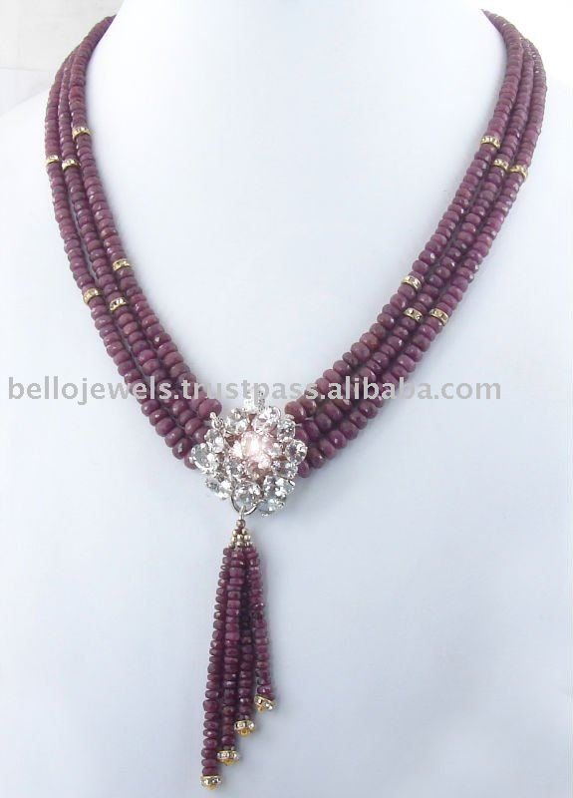
C) Gross Profit or (Loss) is A - B = C

D) Total Fixed Operating Costs are D ($10.00)

E) Profit or Loss Before Taxes is C - D = E

F) Taxes are 25% of E

G) Net Profit or Loss is E - F = G

0000000000000000000
The Beaded A - B = C
Necklace Co. C - D = E
000000000000 E - F = G

A | Total Sales | A = | _________
B | Total Variable Cost (COGS) | B = | _________
C | Gross Profit or Loss | C = | _________
D | Fixed Operating Costs | D = | _________
E | Profit or Loss Before Taxes | E = | _________
F | Taxes | F = | _________
G | Net Profit or (Loss) | G = | _________

+____/7 2. Write an Income Statement for Mythical Windsocks.
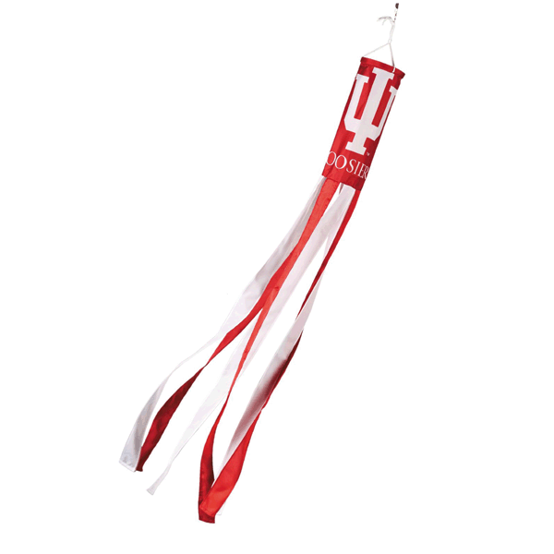
During his first year in college, Travis noticed that some college students liked to buy items that had the name of their home state on them. Travis designed and produced windsocks for several states, and the college bookstore agreed to sell them on consignment. Write a quarterly Income Statement for Travis’ company, Mythical Windsocks, using the following numbers:

(A = $500.00) (B = $252.00) (D = $30.00) (F = 25%)

Mythical A - B = C
Windsocks C - D = E
E - F = G

A | Total Sales | A = | _________
B | Variable Costs incl. COGS | B = | _________
C | Gross Profit or Loss | C = | _________
D | Fixed Operating Costs | D = | _________
E | Profit or Loss Before Taxes | E = | _________
F | Taxes | F = | _________
G | Net Profit or Loss | G = | _________
+____/7 3. Write an Income Statement for Shoulder It All.

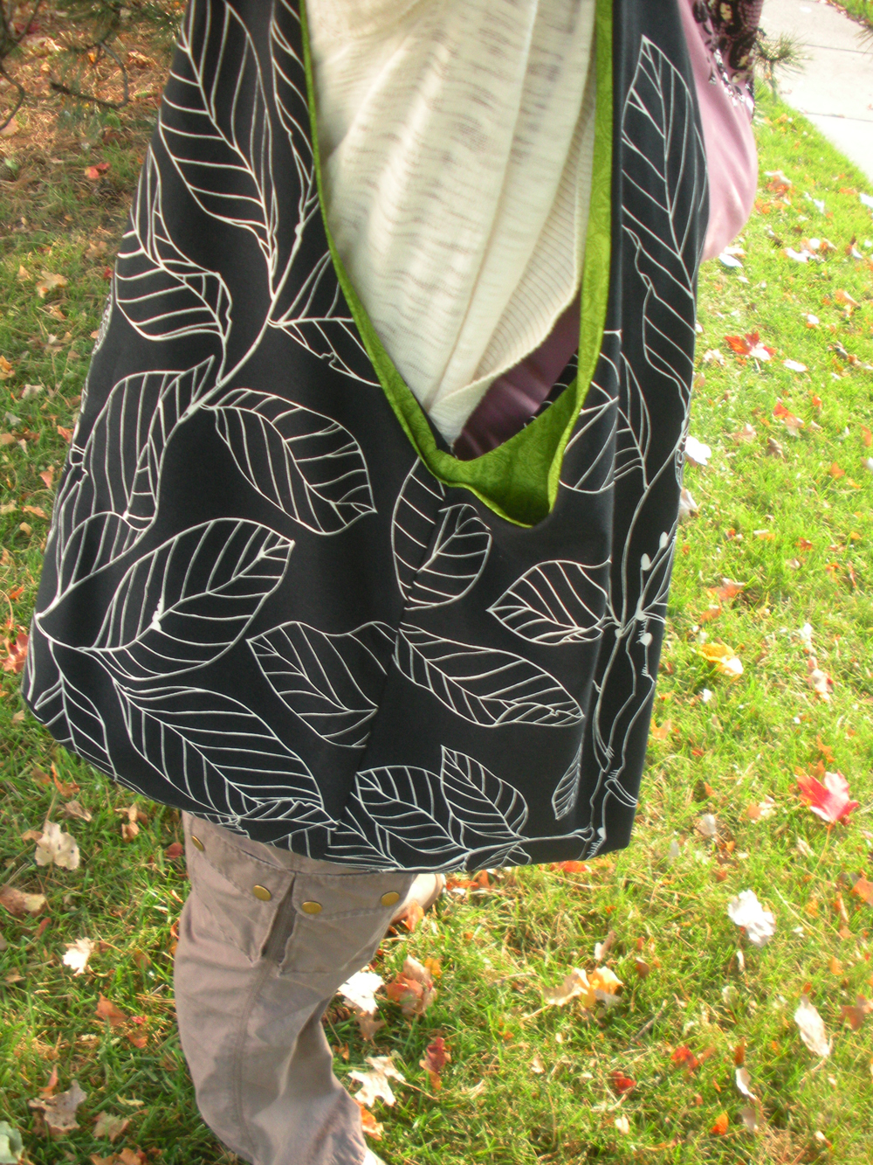
For years, Magdalena made her own handbags. At first, she only made them for friends and family members. Before too long, she had to hire her cousin to help sew and deliver the bags to the dozen boutiques that bought them. Write Magdalena’s income statement using the following numbers:

(A = $31,447.50) (B = $13,387.50) (D = $1,600) (F = 25%)

Shoulder A - B = C
It ALL C - D = E
E - F = G

A | Total Sales | A = | _________
B | Total Variable Costs incl. Total COGS | B = | _________
C | Gross Profit or Loss | C = | _________
D | Fixed Operating Costs | D = | _________
E | Profit or Loss Before Taxes | E = | _________
F | Taxes | F = | _________
G | Net Profit or Loss | G = | _________

+____/7 4. Write an Income Statement for Karen and Diana.

The Holiday Basket is one of the biggest sellers for the mail order catalogue started by Karen and Diana, two young single mothers who wanted to work at their own schedules out of their own homes. The Holiday Basket was introduced in their fifth year of business. Prepare their Income Statement for October through December using the following numbers:

(A = $609,300.00) (B = $167,557.50) (D1 = $9,000.00) (D2 = $750.00) (F = 25%)

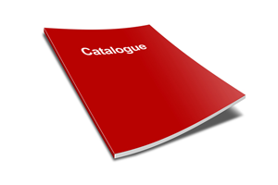

Karen A - B = C
& C - D = E
Diana E - F = G

A | Total Sales | A = | _________
B | Total Variable Costs incl. COGS | B = | _________
C | Gross Profit or Loss | C = | _________
D | Fixed Operating Costs | D = | _________
E | Profit or Loss Before Taxes | E = | _________
F | Taxes | F = | _________
G | Net Profit or Loss | G = | _________

+____/7 5. Write an Income Statement for Bibs for Babes

Nina did a lot of babysitting and got the idea for sewing baby bibs to earn extra money. Prepare her Income Statement with the following information:

24 Baby Bibs sold at a Consumer Price of $6.95 each. The Cost of Goods Sold was $2.75 per bib. There was a Fixed Cost of $10.00 for making copies of an advertising flyer, and Nina paid 25% tax.
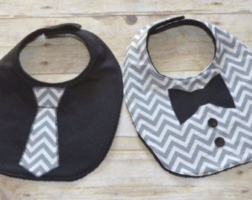

Bibs...

for Babes A - B = C

C - D = E

E - F = G

A | Total Sales | A = | _________
B | Total Variable Costs incl. COGS | B = | _________
C | Gross Profit or Loss | C = | _________
D | Fixed Operating Costs | D = | _________
E | Profit or Loss Before Taxes | E = | _________
F | Taxes | F = | _________
G | Net Profit or Loss | G = | _________

+____/7 6. Write an Income Statement for Sibling’s Tees.

Write an Income Statement based on the following: A sister and brother spent their spring vacation tie-dying 200 T-shirts to sell over the summer. They sold all 200 shirts in July. The Selling Price was $12.95 per shirt. Their Total Cost of Goods Sold was $6.35 each. They spent $100 on advertising (a Fixed Operating Cost). They paid 25% in taxes.

(A = $2,590.00) (B = $1,270.00) (D = $100.00) (F = 25%)

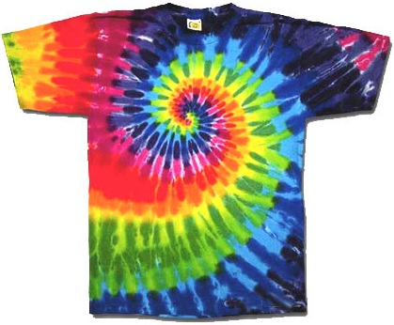
TTTTTTTTTTTTTTTTT

Sibling’s Tees A - B = C

C - D = E
TTTTTTTTTTTTTT
E - F = G

A | Total Sales | A = | _________
B | Total Variable Costs incl. COGS | B = | _________
C | Gross Profit or Loss | C = | _________
D | Fixed Operating Costs | D = | _________
E | Profit or Loss Before Taxes | E = | _________
F | Taxes | F = | _________
G | Net Profit or Loss | G = | _________

+____/7 7. Write an Income Statement for Morgan’s Hair Stuff.

Write an Income Statement for this young entrepreneur. Morgan sold a total of 350 Daisy Hair Scrunchies at five street fairs. The Total Variable Costs including Cost of Goods Sold was $0.96 each. The Selling Price was $5.00 each. Morgan had no Fixed Operating Costs, but paid 25% in taxes.

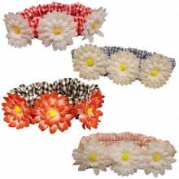
///// \\\\\\\\\

Morgan’s A − B = C

Hair C – D = E

Stuff E − F = G

A | Total Sales | A = | _________
B | Total Variable Costs | B = | _________
C | Gross Profit or Loss | C = | _________
D | Fixed Operating Costs | D = | _________
E | Profit or Loss Before Taxes | E = | _________
F | Taxes | F = | _________
G | Net Profit or Loss | G = | _________

+____/7 8. Write an Income Statement for Malcolm’s Time.

Malcolm wants to find out if his business is profitable and if he should continue building and selling quartz clocks. He decides to put together an Income Statement. Compile one with the following information:

His Total Cost of Goods Sold was $16.01 per clock. During the relevant time period, he sold 150 clocks at a price of $39.00 each. He spent $495.00 on power tools (a Fixed Operating Cost), and he paid 25% tax.

Malcolm’s A - B = C

TIME C - D = E

E - F = G

A | Total Sales | A = | _________
B | Total Cost of Goods Sold | B = | _________
C | Gross Profit or Loss | C = | _________
D | Fixed Operating Costs | D = | _________
E) | Profit or Loss Before Taxes | E = | _________
F) | Taxes | F = | _________
G) | Net Profit or Loss | G = | _________

Is Malcolm’s business profitable enough that he should continue building and selling quartz clocks?

+____/7 9. Write an Income Statement for Jump Street.

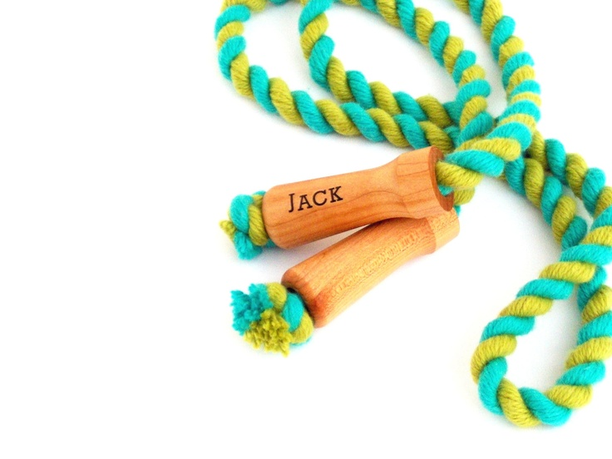
A father and his daughter made a jump rope as a birthday present. Everyone in the family liked it so much, the daughter decided to make more ropes to sell. In the first month of business, she sold 75 customized ropes for $10.00 each. The Total Variable Costs including COGS was $2.40 per rope. Her Fixed Operating Costs were $5.95 and she paid 25% tax. Prepare an Income Statement for her.

A - B = C

JUMP Street C - D = E
E - F = G

A | Total Sales | A = | _________
B | Total Variable Costs incl. COGS | B = | _________
C | Gross Profit or Loss | C = | _________
D | Fixed Operating Costs | D = | _________
E | Profit or Loss Before Taxes | E = | _________
F | Taxes | F = | _________
G | Net Profit or Loss | G = | _________

+____/7 10. Write an Income Statement for Candle Bright.

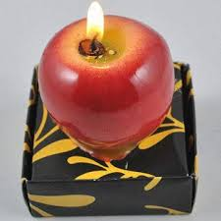
Keela learned to make candles when she was in the Girls Scouts. She decided to use this skill to earn some extra money. She made 100 apple-shaped candles to sell over the holidays. The Cost of Goods Sold per candle was $3.60. She sold 75 candles at $8.00 each. She had no Fixed Operating Costs, and she paid 25% tax. Write up an Income Statement using these figures.

()
#######

CANDLE A - B = C

Bright C - D = E

E - F = G

A | Total Sales | A = | _________
B | Total Cost of Goods Sold | B = | _________
C | Gross Profit or Loss | C = | _________
D | Fixed Operating Costs | D = | _________
E | Profit or Loss Before Taxes | E = | _________
F | Taxes | F = | _________
G | Net Profit or Loss | G = | _________

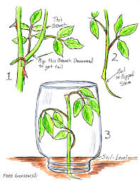
+____/9 11. Leon started his plant business, Plentiful, with cuttings and transplants from his grandmother’s garden. Now in its fifth year, Plentiful needs an Income Statement for a Seed Starter Tray. Leon sold 5,510 of these gift trays at a consumer price of $12.00 each. His Total Cost of Goods Sold (B1) was $3.08 each; his Other Variable Costs (B2) were $850.00. His Fixed Operating Costs were $2,750.00. He paid 25% tax. Use the Income Statement calculation to figure out Leon’s profit or loss from this business.

A – (B1 + B2) = C Remember: B1 = COGS;
B2 = Other Variable Costs
C − D = E
E − F = G

A | Total Sales | A = | _________
B | Total Variable Costs  (B1 + B2)  B1 Cost of Goods Sold _____  B2 Other Variable Costs _____ | B = | _________
C | Gross Profit or Loss | C = | _________
D | Fixed Operating Costs | D = | _________
E | Profit or Loss Before Taxes | E = | _________
F | Taxes | F = | _________
G | Net Profit or Loss | G = | _________

+____/5 12. Sea Shell Picture Frames sold very well at the beach gift shop during the summer season. The store sold 1,008 at $20.00 each. The Total Cost of Goods Sold was $9.00 each. Fixed Operating Costs were $1,000.00, and Other Variable Costs were $350.00. The tax rate is 25%. Were the items profitable as well as popular?

How profitable?

+____/5 13. Rebecca built her first bird feeder when she was eleven, from a plan she had found on the back of a cereal box. Her company, Straighten Up and Fly Right, now has sales of nearly half a million dollars a year. She needs an Income Statement for her Martin Bungalow Wooden Bird Feeder. Over the period of this statement, her company sold 9,800 Bungalows for $19.00 each. The Total Cost of Goods Sold on each feeder was $8.35. Her Fixed Operating Costs were $10,000.00, and her Other Variable Costs were $800.00. She pays 25% tax. What profit did Rebecca make?

+____/5 14. Andre made a video of the reunion concert of the Gross Prophets, his favorite band. The first weekend, he sold 98 copies at a Consumer Price of $50.00 each. His Total Cost of Goods Sold was $43.05 per tape. He had no Fixed Operating Costs, but disbursed $1,000 in Other Variable Costs. His tax rate was 25%. Where could Andre make some changes in his entrepreneurial venture to make it more profitable?

+____/5 15. After a four-day weekend of selling Rice Krispies® Treats outside her home, Chelsea wanted to figure out how much profit her business made. 180 squares sold at $.50 each; Total Cost of Goods Sold was $.26 per square. She had no Fixed Costs, but she distributed flyers – an Other Variable Cost of $5.00. Chelsea paid 25% tax. What was her profit?

+____/5 16. Ti hand-printed greeting cards and sold them through his mother’s gift store. For the period he considered, he sold 91 cards at $3.00 each. His Total Cost of Goods Sold was $1.25 per card. He had a Fixed Operating Cost of $4.95 and no Other Variable Costs. His tax rate is 25%. How much profit did Ti make?

+____/5 17. Alex made a DVD-case cover as a Mother's Day present. Since his mother’s friends admired them, he decided to go into business. The first week, he sold 29 covers at $5.00 each. His Total COGS was $2.69 apiece. He had a Fixed Operating Cost of $7.95 and no Other Variable Costs. He paid 25% tax. How much profit did Alex earn?

+____/5 18. What was the profit or loss for The Box in the Window company based on the following numbers: 45 Window Boxes sold at a cost of $25.00 each; the Total Cost of Goods Sold was $4.79 each; Fixed Operating Costs were $525.00; and Other Variable Costs were $381.50. The business pays taxes of 25%.

+____/5 19. Camilla went out crabbing every morning and supplied her friend’s local seafood restaurant, The Chesapeake, with soft-shell crabs all summer. Halfway through the season, Camilla and her friend decided to write an Income Statement so they could see the profitability of her operation clearly in numbers. Use the following figures to determine the loss of profit from the venture: 620 Soft-Shell Crab Sandwiches sold at $12.50 each; Total Cost of Goods Sold is $2.77 per sandwich; there is an Other Variable Cost of $75.00 and a Fixed Operating Cost of $375.00. The Restaurant pays taxes at a rate of 25%.

+____/5 20. During an unusually hot July, an ice cream stand compiled the following numbers on one of their biggest sellers — the Black and White Milkshake − during the month of July: 1,301 milkshakes sold at $3.69 each. The Total Cost of Goods Sold was $1.75 per shake. Fixed Operating Costs: $430.00; Other Variable Costs: $32.00. The tax rate is 25%. How profitable for the store was this popular product?

+____/5 21. The ice cream store business in question 20 actually had Total Fixed Operating Costs for July of $4300.00. Why might the ice cream store have decided to charge only $430.00 of that amount to the Income Statement for Black and White Milkshakes?

________________________________________________________________

________________________________________________________________

________________________________________________________________

+____/5 22. In question 19, The Chesapeake reported Other Variable Costs of $75.00. What might those expenses have been?

________________________________________________________________

________________________________________________________________

________________________________________________________________

+____/62 pts. 2.4 Return on Investment (ROI)

Return on Investment is the net profit on an investment expressed as a percentage of the initial investment.

Net Profit
ROI = Investment X 100
Think: times 100 because ROI is expressed as a %.

Remember: Net Profit = (A – B)

A = Value of investment at the end of the period
B = Value of initial investment (what you started with)

Example:

Type  of Investment | A  (value of  investment  at the end of the period) | B  (value of  initial  investment) | Net Profit  (A − B) | ÷ B | X 100 | Return on Investment  (ROI)
Make and sell leather jackets | $15,000.00 | $10,000.00 | $15,000 −$10,000  $ 5,000 | 5,000  ÷ 10,000  = .5 | .5  X 100 | = 50%
Make and sell beaded necklaces | $400 | $200 | $400  −$200  $200 | 200  ÷  200  = 1 | 1  X 100 | = 100%

+_______/44 1. Determine the Return on Investment (ROI) for the following businesses: Remember to round decimals as needed.

Type  of  Investment | A  (value of  investment  at the end  of the period) | B  (value of  initial  investment) | Net Profit  (A − B) | ÷ B  (÷ value of  initial  investment) | X 100  (to convert to a percentage) | %  Return  on Investment  (ROI)
Windsock  business | $1,000 | $500
Sling Bag  business | $100,000 | $25,000
Holiday  Basket  business | $750,000 | $500,000
Baby Bib  business | $300 | $100
Tie-Dyed  T-Shirt business | $5,000 | $1,500
Hair Scrunchy  business | 1,500 | $500
Quartz  Clock business | $6,000 | $3,000
Jump Rope  business | $750 | $200
Apple Candle  business | $100 | $100
Seed Tray  business | $50,000 | $40,000
Sea Shell Frame  business | $8,000 | $200

+_______/13 2. Complete the table. Add any missing information.

Type  of  Investment | A  (value of  investment  at the end  of the period) | B  (value of  initial  investment) | Net Profit  (A − B) | %  Return  on Investment  (ROI)
Bird  Feeder sales | $250,000 | $100,000 | $150,000
Demo Tape Duping business | (-$500) | $2,000 | -$2,500
Rice  Krispies®  Treat sales |  | $20 | $40 | 200%
Greeting  Card sales | $150 |  | $100 | 200%
DVD Case  Cover business |  | $25 | $150 | 600%
Window  Box sales | $500 |  | $250
Crab  Sandwich  sales |  | $1,000 | $9,000
Milk-  Shake sales |  | $250 | $2,250
Swim Team Fund-raiser  Concert | $3,700 | $3,700

+_______/5 3. If Jerome invested $450 to start and operate his business for one year and his total sales for that period were $450, did he really break even? Why?

________________________________________________________________

________________________________________________________________

________________________________________________________________

